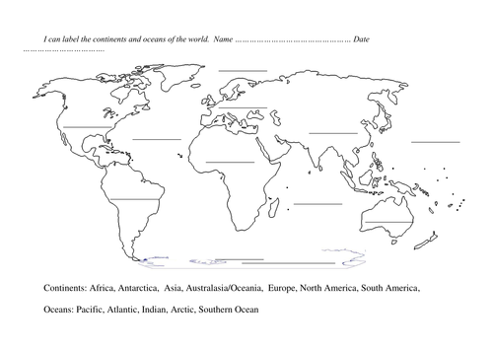

**Continents**: Label: North America, South America, Africa, Asia, Europe, Australia/Oceania (I already typed in Antarctica.) **Color each continent a different color**. Use only colored pencils. Lightly shade. Do not color too dark or we can’t see the words. Don’t use black or grey to shade at any time on the map.

**Oceans**: Label the Atlantic, Arctic, Indian, Southern, & the Pacific (label 2 spots on the map for Pacific),

Draw **blue waves** next to the label for **each ocean** on the map

In the **KEY**, put in the color for each continent/ **and show that oceans are represented by waves**

ALWAYS use a **black pen** to label a map,

Draw a compass on the map (N,S,E,W)

Draw a **line and label** the location of the **Equator**. I have rulers.

**Never** use markers, highlighters, or crayons. Always use a black pen to write & colored pencils to shade

Be neat. Points will be taken off if you don’t follow these directions.

KEY

Antarctica

**______**

**________**__

**______________**__

Name: ____________________________________________________________ Date: _____________________ Period: _____________

**Mrs. Harrington / World History Honors Label the Continents and Oceans of the World (**This assignment is worth 20 points)